Tagging

What is Tagging?
# Source: AI Source: Provided by: [Data Path: Persons Table -> ID Column: 1, Name_En Column: Motasem Essam] -> From: [ChatGPT] on [2/15/2026]
In the context of a version control system (VCS), tagging is a way to mark a specific point in the repository’s history with a human-readable name. Tags are usually used to denote important versions of your project, such as releases, milestones, or stable snapshots.
Think of it as putting a label on a particular commit so you can easily reference it later.

Key Points About Tagging
# Source: AI Source: Provided by: [Data Path: Persons Table -> ID Column: 1, Name_En Column: Motasem Essam] -> From: [ChatGPT] on [2/15/2026]
- Marks a specific commit: A tag points to a commit in the history—it doesn’t change like a branch.
- Read-only reference: Unlike branches, tags don’t move forward; they’re fixed.
- Used for releases: Developers often tag versions like v1.0, v2.1.3, or release-2026-02-16 to mark official releases, Marking milestones or important points in history
- Easy to checkout: You can check out the code at a tag to see exactly what the project looked like at that point.
- Tags are not branches: They don’t move like branches do, they are fixed references to a specific commit

Two types of tags
# Source: AI Source: Provided by: [Data Path: Persons Table -> ID Column: 1, Name_En Column: Motasem Essam] -> From: [ChatGPT] on [2/15/2026]
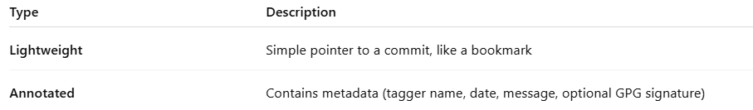
Type | Description
Lightweight | Simple pointer to a commit, like a bookmark
Annotated | Contains metadata (tagger name, date, message, optional GPG signature)

How to create a tag
# Source: AI Source: Provided by: [Data Path: Persons Table -> ID Column: 1, Name_En Column: Motasem Essam] -> From: [ChatGPT] on [2/15/2026]
1. Lightweight tag
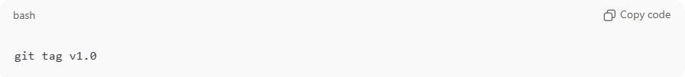
git tag v1.0
2. Annotated tag
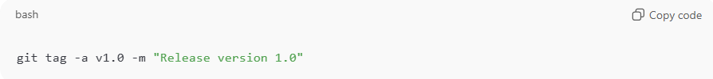
git tag -a v1.0 -m "Release version 1.0"

How to view tags
# Source: AI Source: Provided by: [Data Path: Persons Table -> ID Column: 1, Name_En Column: Motasem Essam] -> From: [ChatGPT] on [2/15/2026]
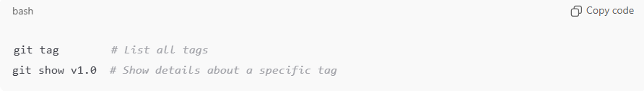
git tag # List all tags
git show v1.0 # Show details about a specific tag

How to push tags to remote
# Source: AI Source: Provided by: [Data Path: Persons Table -> ID Column: 1, Name_En Column: Motasem Essam] -> From: [ChatGPT] on [2/15/2026]
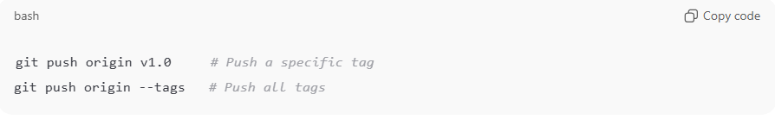
git push origin v1.0 # Push a specific tag
git push origin --tags # Push all tags

Analogy
# Source: AI Source: Provided by: [Data Path: Persons Table -> ID Column: 1, Name_En Column: Motasem Essam] -> From: [ChatGPT] on [2/15/2026]
- Branch = moving pointer → keeps changing as commits are added
- Tag = sticky note → stays fixed on a specific commit

💡 Memory trick:
# Source: AI Source: Provided by: [Data Path: Persons Table -> ID Column: 1, Name_En Column: Motasem Essam] -> From: [ChatGPT] on [2/15/2026]
Tags = labels on important commits → usually for software versions or milestones ✅

Example in Git
# Source: AI Source: Provided by: [Data Path: Persons Table -> ID Column: 1, Name_En Column: Motasem Essam] -> From: [ChatGPT] on [2/15/2026]
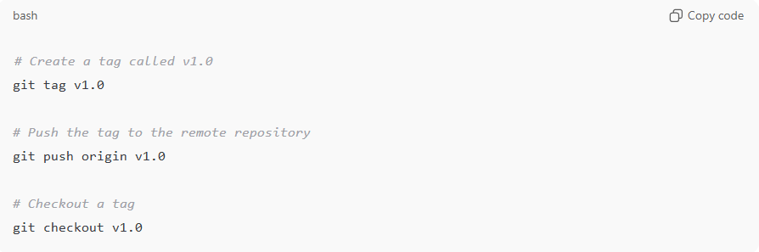
# Create a tag called v1.0
git tag v1.0

# Push the tag to the remote repository
git push origin v1.0

# Checkout a tag
git checkout v1.0
Here:
- v1.0 could represent the first stable release of your project.
- Anyone can now access that exact state of the code without worrying about ongoing changes in branches.

In short: Tags are like bookmarks for specific versions in your project’s history, making it easy to reference and release stable versions.

